

**MATHEMATICS:**

**SPECIALIST 1 & 2**

**SEMESTER 1 2018**

**TEST 2**

**Name_____________________**

**Calculator Free**

Reading time: 2 mins

Time allowed: 18 mins Total marks: 17

**1.** [6 marks]

For the statement: The vehicle is a car then the vehicle has four wheels

Write down the converse, inverse and contrapositive statements and state whether they are true or false.

|  |  |  |
| --- | --- | --- |
|  | Statement | True/False |
| Converse |  |  |
| Inverse |  |  |
| Contrapositive |  |  |

**2.** [7 marks: 1, 2, 1, 3]

Three vectors are defined as **a** = 3**i**+9**j**, **b** = **i**-3**j** and **c** = -3**i**-4**j**.

All answers to this question should be written in an exact form if they cannot be evaluated.

a) What is $\left|a\right|$?

b) What is the unit vector $\hat{b}$?

c) Find a vector in the same direction as **b** but is 7 units in length.

d) Find a vector that is the same direction as **c** but is twice the length of **b**.

**3.** [4 marks]

Prove the following statement using proof by contradiction.

The points A (2,3), B (-6,8) and C (-2,-3) are not collinear.



**MATHEMATICS:**

**SPECIALIST 1 & 2**

**SEMESTER 1 2018**

**TEST 2**

**Name_____________________**

**Calculator Assumed**

Reading time: 3 mins

Time allowed: 42 mins Total marks: 35

**4.** [3 marks]

A displacement of (3**i**+2**j**) m is followed by a displacement of (7**i**-6**j**) m. Find the magnitude and direction of the resultant displacement, giving your answers to 1 decimal place.

**5.** [2 marks]

Damien walks 75m on a bearing of 040°. Taking **i** and **j** as the unit vectors in the directions east and north respectively, find his displacement. Give your answer in the form a**i** + b**j** where a and b are rounded to 1 decimal place.

**6.** [9 marks: 2, 2, 1, 1, 2]

A triangle OAB has midpoints on its sides Q, R and S as shown in the diagram below.

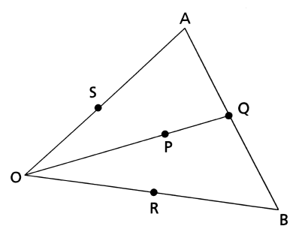

$\vec{OA }$ = **a** and $\vec{OB }$ = **b**.

P is a point $\frac{2}{3}$ of the way along Q.

a) Express $\vec{AQ }$ in terms of **a** and **b**.

b) Express $\vec{OQ }$ in terms of **a** and **b**. Hence, or otherwise, express $\vec{OP }$ in terms of **a** and **b**.

c) Express $\vec{AR }$ in terms of **a** and **b**.

d) T is a point $\frac{2}{3}$ along AR. Express $\vec{AT }$ in terms of **a** and **b**.

e) Using your answer to d), express $\vec{OT }$ in terms of **a** and **b**. What does this tell you about points P and T?

**7.** [5 marks]

The three forces shown in this diagram are in equilibrium. Find the values of P and Q.

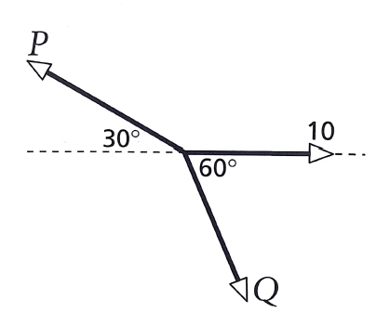

**8.** [3 marks]

Determine the coordinates of point B given that **r**A=6**i**-4**j** and A**r**B=-2**i**+4**j**.

**9.** [6 marks]

To a person travelling in a car at 110km/h on a bearing of 035° the wind appears to come from a bearing of 330° at 76km/h. Find the true velocity and direction of the wind.

**10.** [8 marks]

A pilot needs to fly from Perth to Singapore which is a distance of 3900km on a bearing of 315°.

A Boeing 777 can fly at 892km/h in still air. On the particular day of the flight, there is a wind of (16**i**+24**j**)km/h blowing.

Find the velocity vector (in the form a**i**+b**j**) that the pilot should set and the time the flight will take.